**PROJECT REPORT**

**UNEARTHING THE ENVIRONMENTAL IMPACT OF HUMAN ACTIVITY**

**A GLOBAL CO2 EMISSION ANALYSIS**

1. **INTRODUCTION**

**1.1. Overview**

CO2 Emission is the main topic in different ongoing debates on sustainable development

and ecological protection. CO2 is an important heat-trapping gas that comes from the

extraction and burning of fossil fuels such as Cola, Oil and Natural gas. CO2 in the

atmosphere warms the planet, causing Global Warming and Climate Change. Human

activities have raised the atmosphere’s carbon dioxide content by 50% in less than 200

years.

**1.2. Purpose**

Focusing on CO2 emissions and its effect on the world and some key factors that play a

major role in the emission of CO2 globally. This will help researchers and environmental

experts to predict Global Warning. So countries should set a goal to decrease the

emissions.

**2. PROBLEM DEFINING AND DESIGN THINKING**

**2.1. Empathy Map**

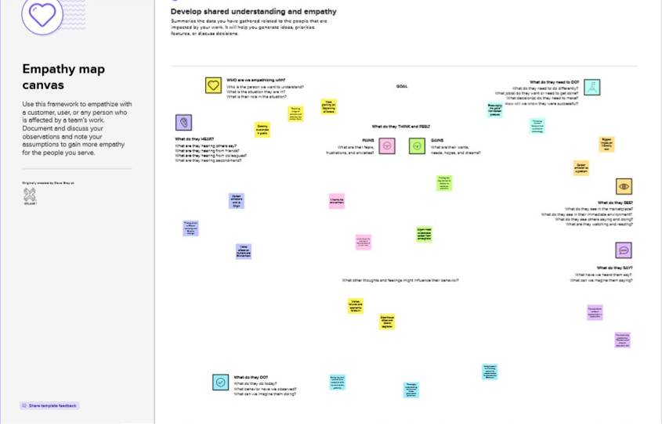

**2.2. Ideation and Brainstorming Map**

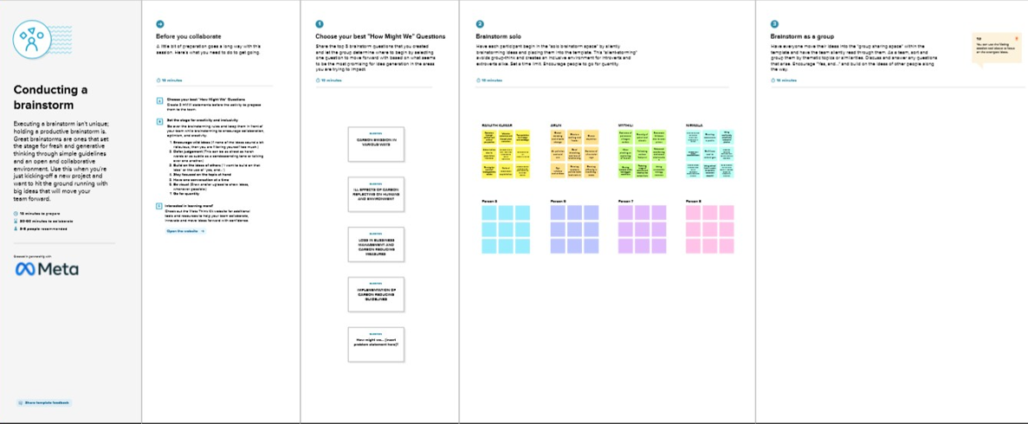

**3.RESULT**

The Outputs of Data Visualization

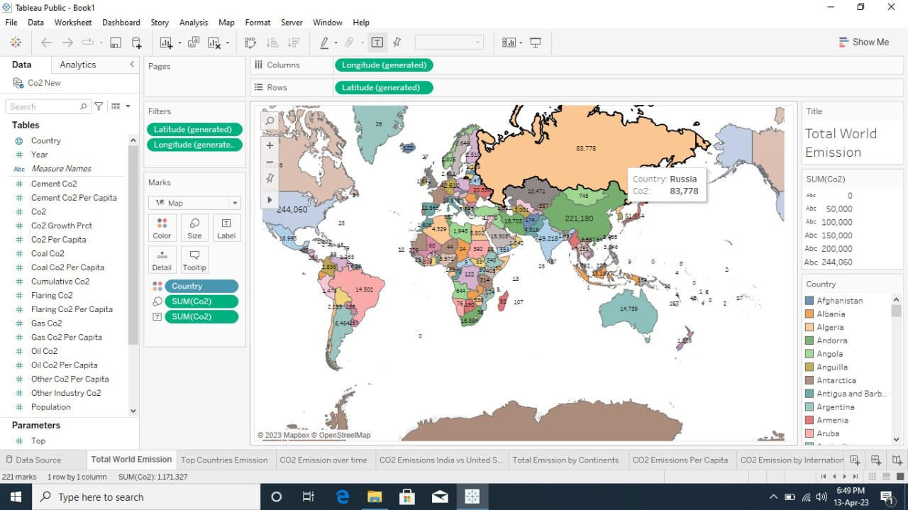**3.1. Top World Emission**

**­­­­­­­­­­­­­­**

**3.2. Top Emitting Countr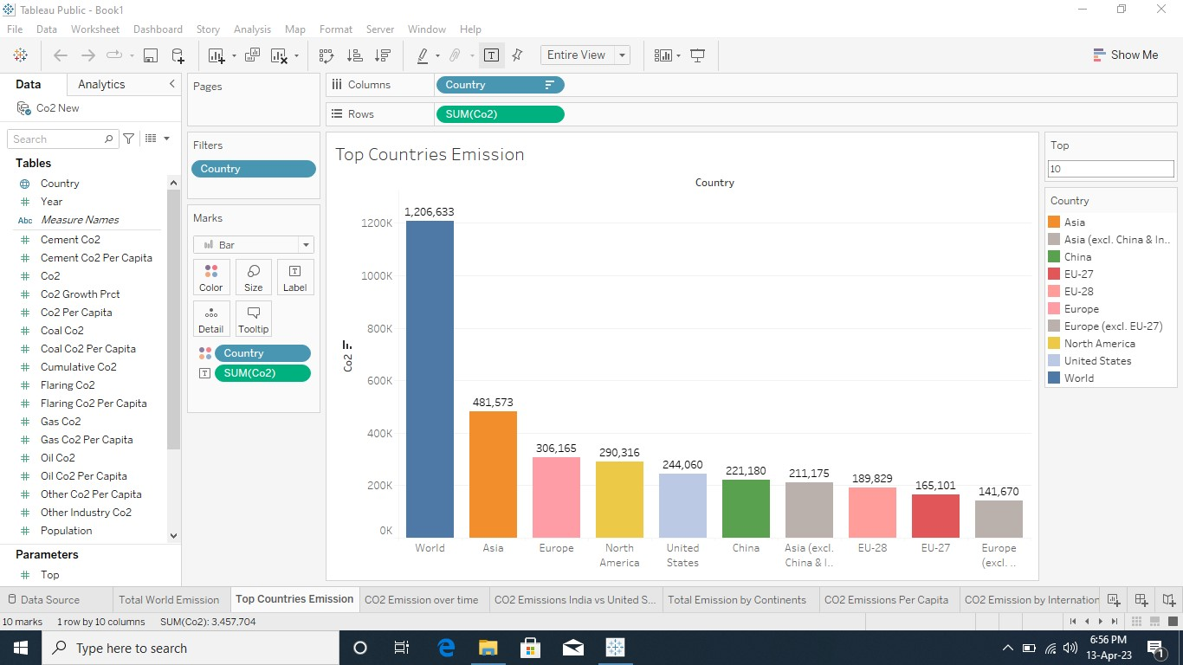ies**

**3.3. CO2 Emission Over Time**

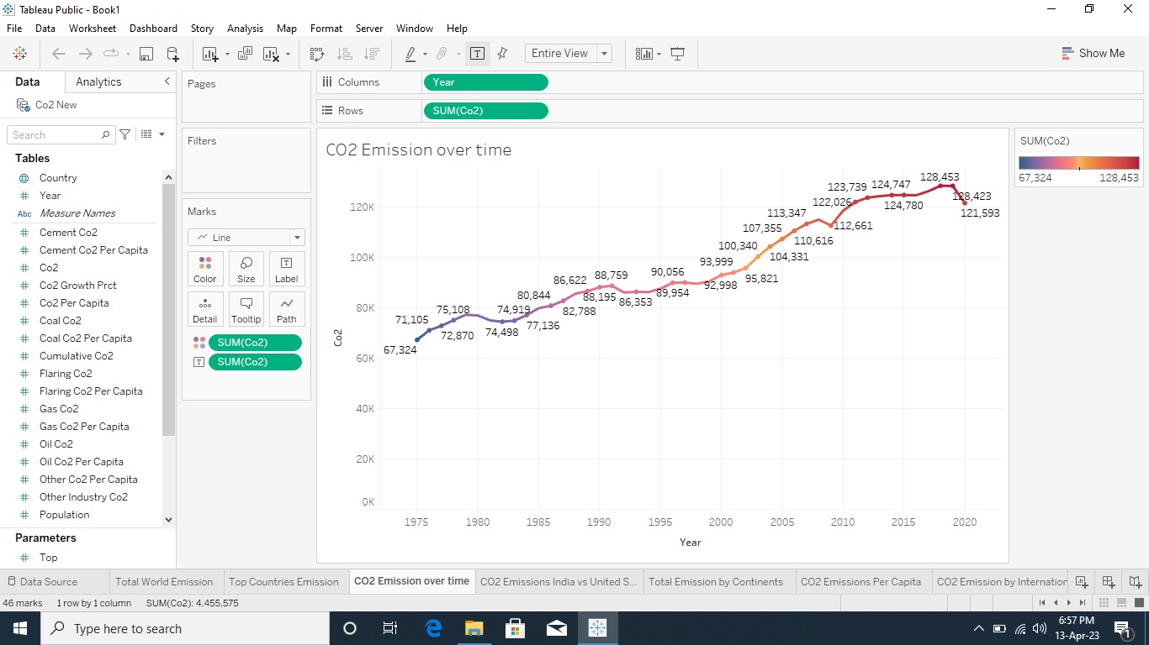

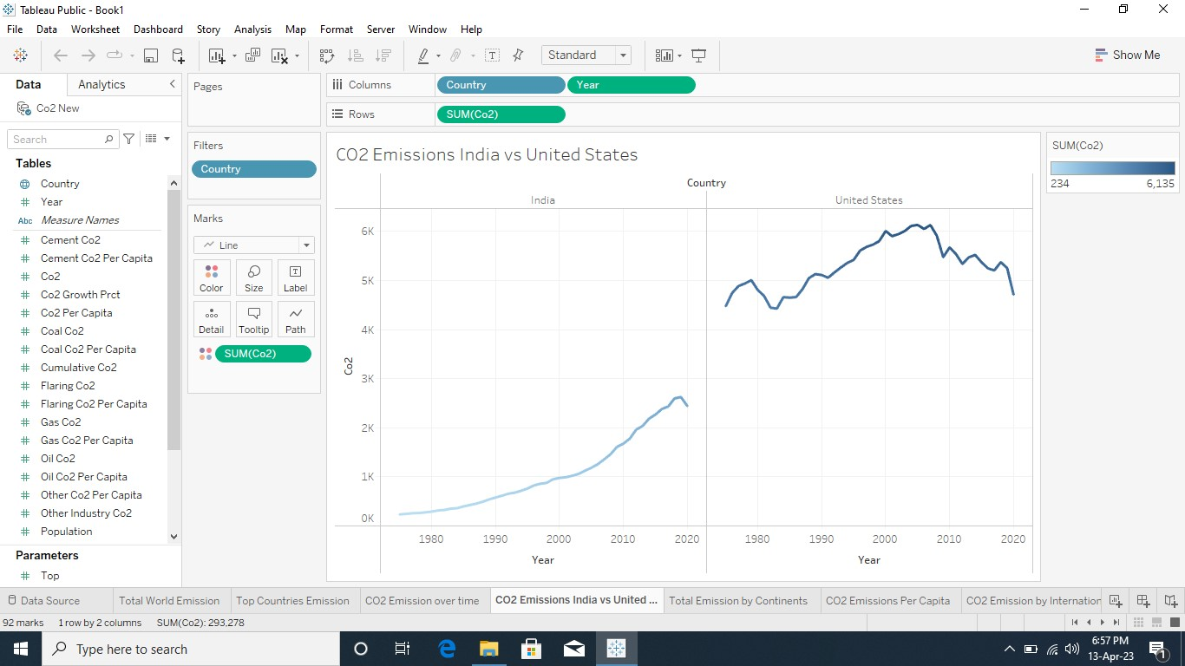 **3.4. CO2 Emission India vs USA**

**3.5. Total Emission by Continents**

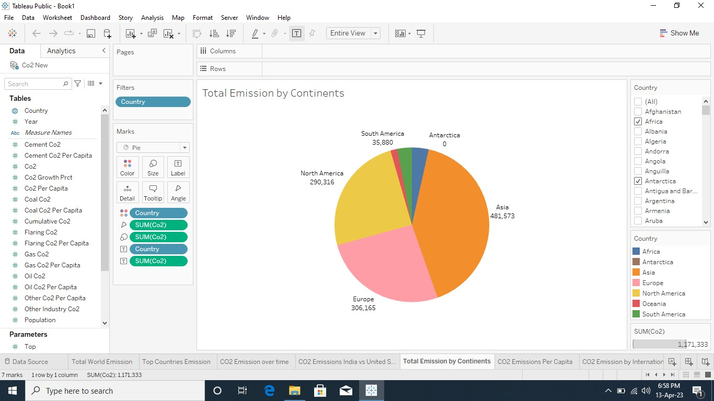

**3.6. CO2 Emission Per Capita**

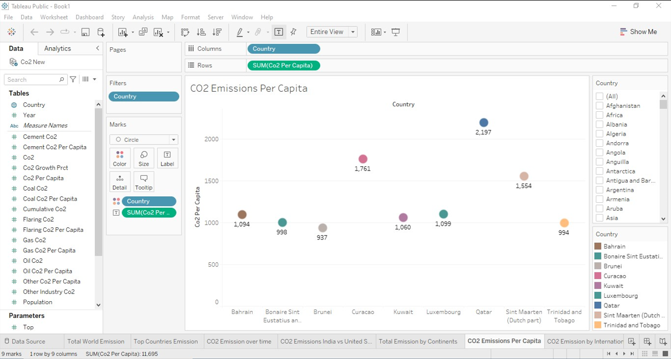

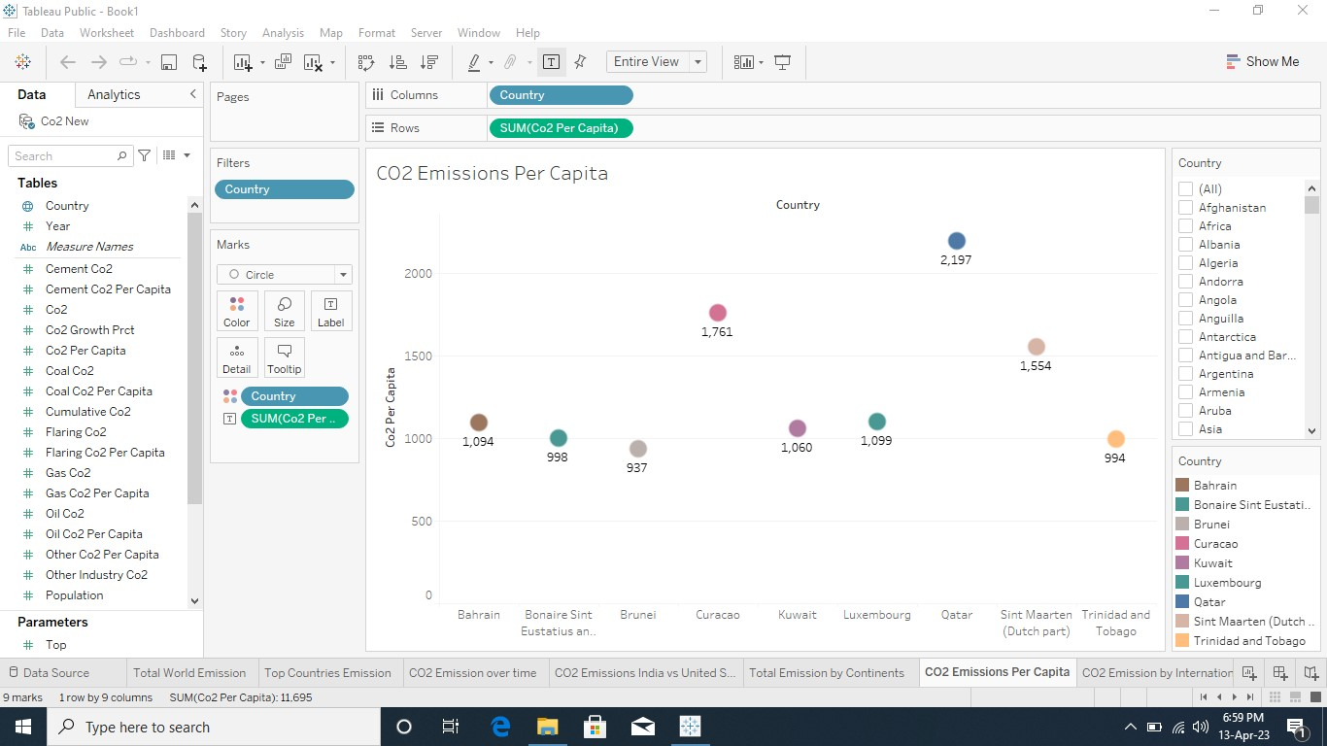**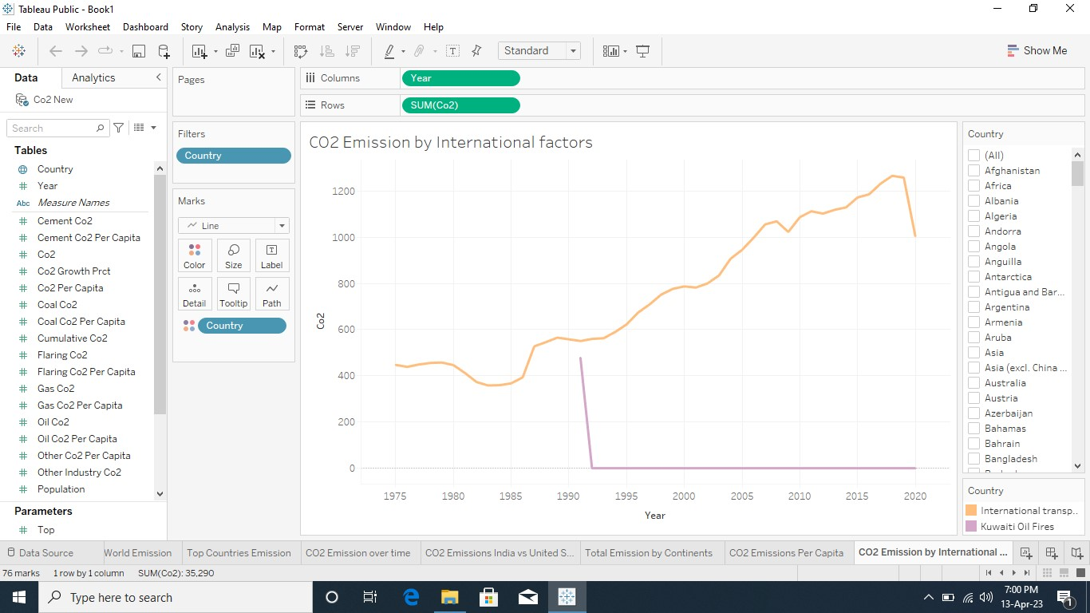3.7. CO2 Emission by International Factors**

**3.8. Emission Rate Over 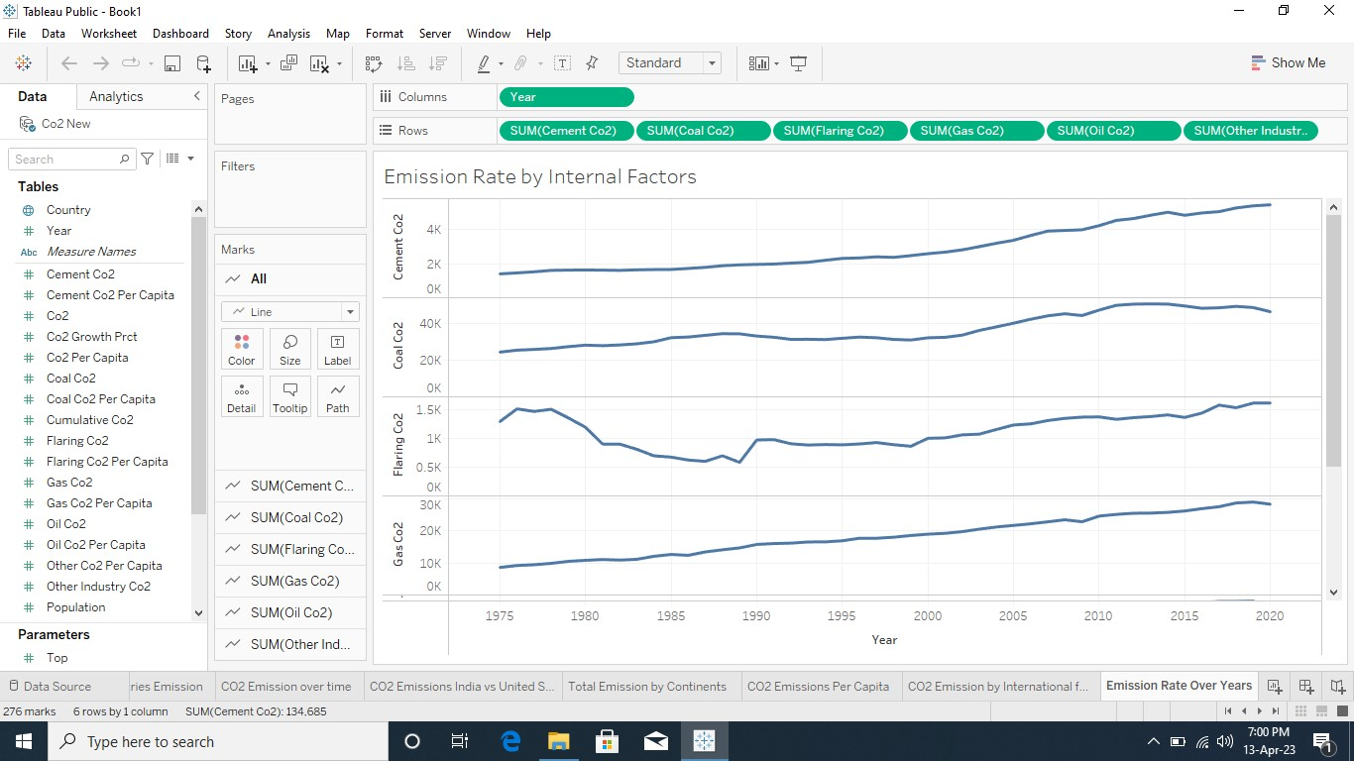Year**

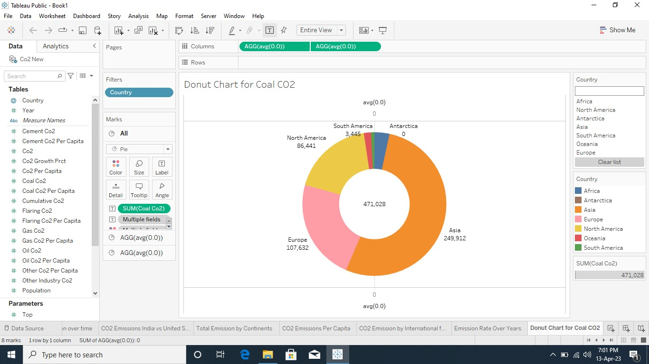**3.9. Donut Chart for Coal CO2**

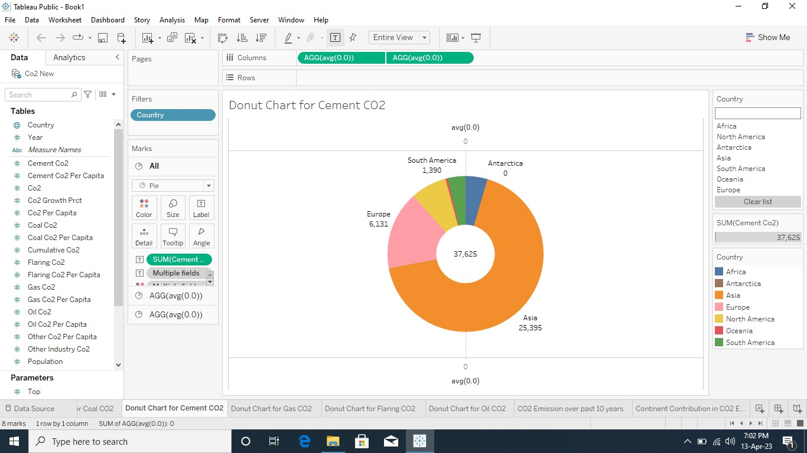**Donut Chart for Cement CO2**

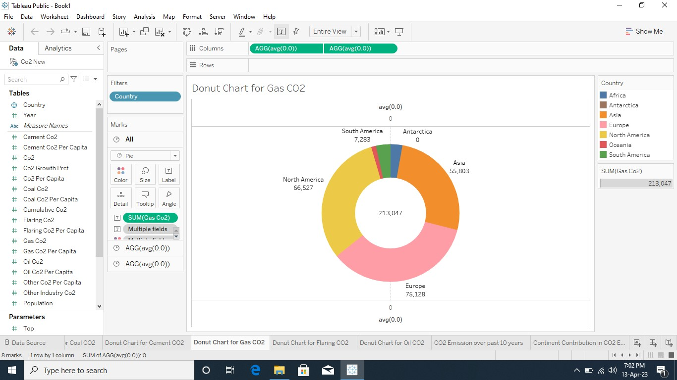**Donut Chart for Gas CO2**

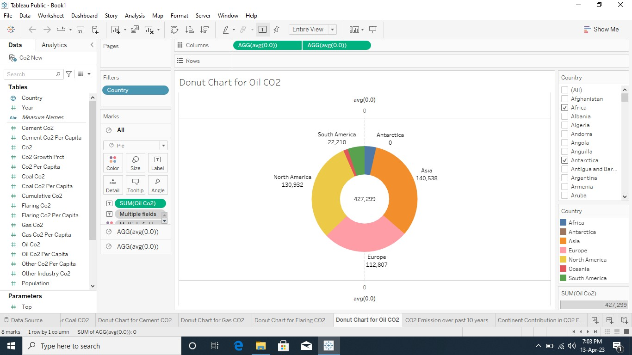**Donut Chart for Oil CO2**

**3.10. CO2 Emission Over Past 10 Years**

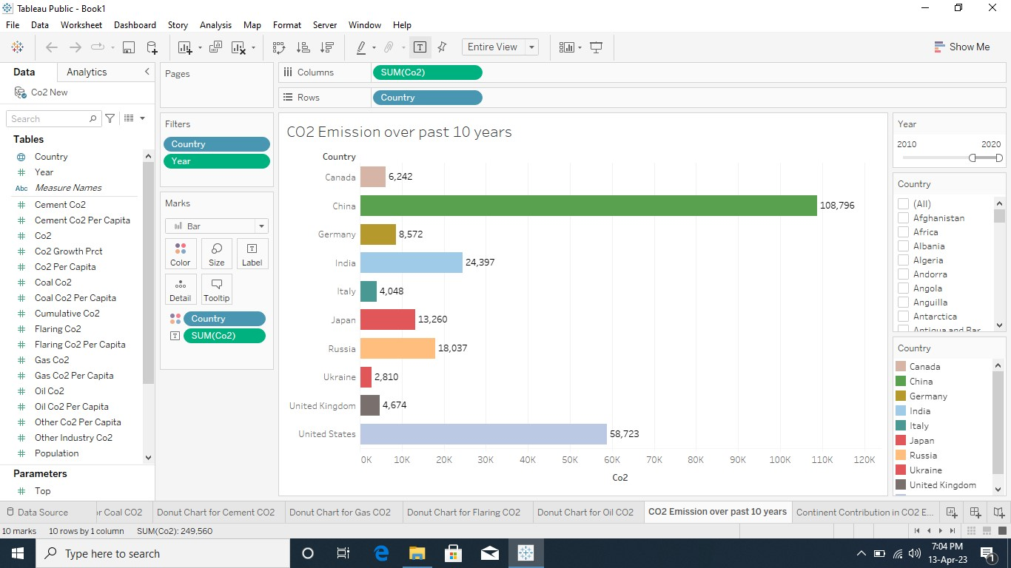

**3.11. Continent Contribution in CO2 Emission**

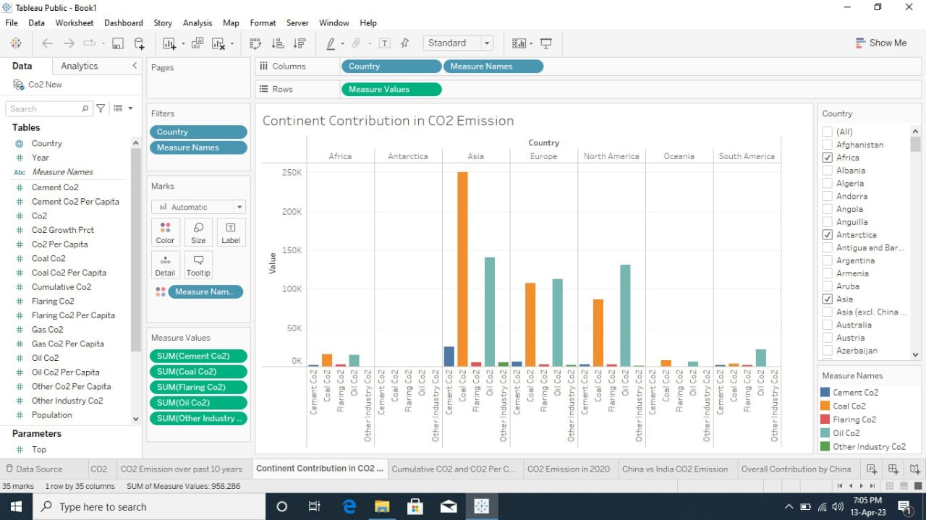

**3.12. Cumulative CO2 and CO2 Per Capita over Years**

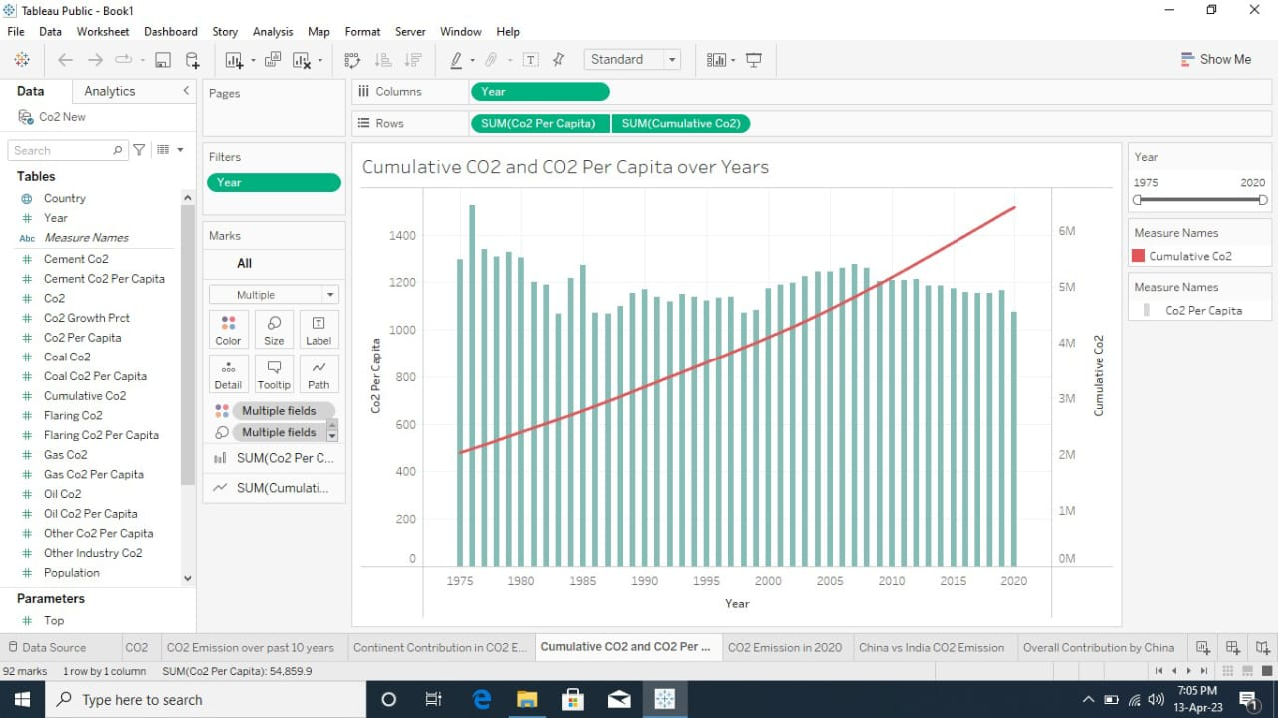

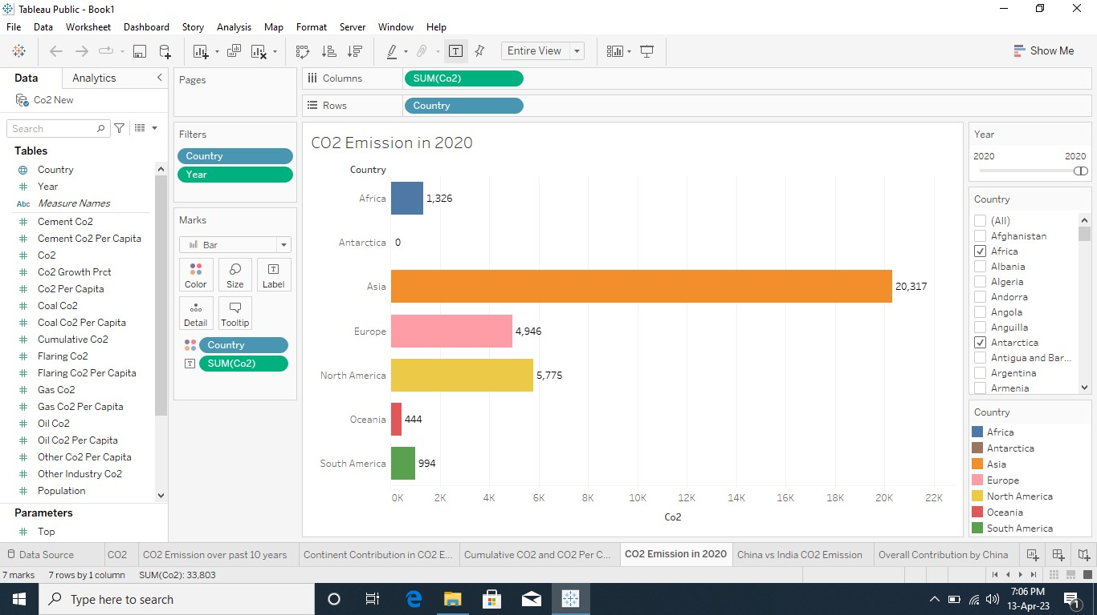

**3.13. CO2 Emission in 2020**

**3.14. China vs India CO2 Emission due to Internal Factors**

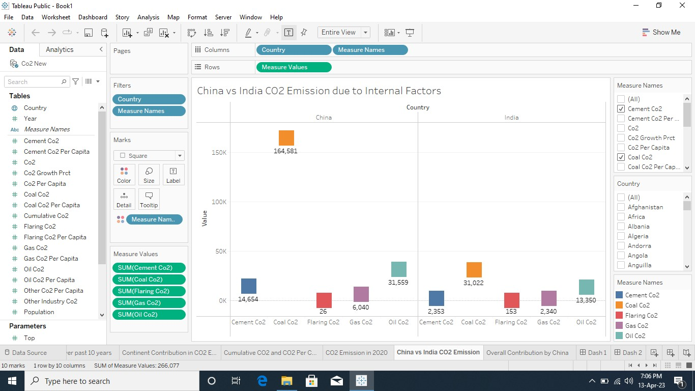

**3.15. Overall Contribution by China in 2020 Emission**

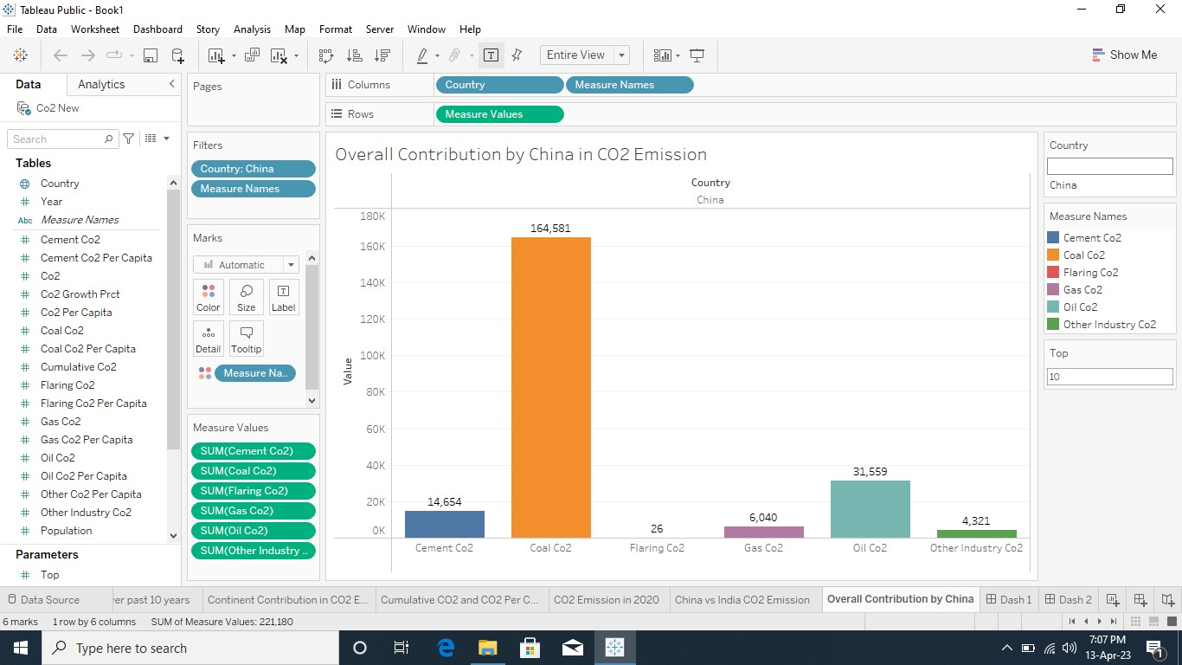

**3.16. Dashboard**

**Dashboard – 1**

[**https://public.tableau.com/views/Book1dashboard1_16814428978390/Dash1?:language=en-US&:display_count=n&:origin=viz_share_link**](https://public.tableau.com/views/Book1dashboard1_16814428978390/Dash1?:language=en-US&:display_count=n&:origin=viz_share_link)

**Dashboard – 2**

[**https://public.tableau.com/views/Book1dashboard2_16814430954810/Dash2?:language=en-US&:display_count=n&:origin=viz_share_link**](https://public.tableau.com/views/Book1dashboard2_16814430954810/Dash2?:language=en-US&:display_count=n&:origin=viz_share_link)

**Dashboard – 3**

[**https://public.tableau.com/views/Book1dashboard3/Dash3?:language=en-US&:display_count=n&:origin=viz_share_link**](https://public.tableau.com/views/Book1dashboard3/Dash3?:language=en-US&:display_count=n&:origin=viz_share_link)

**3.17. Story**

[**https://public.tableau.com/views/Book1_16812296548930/CO2EmissionStory?:language=en-US&:display_count=n&:origin=viz_share_link**](https://public.tableau.com/views/Book1_16812296548930/CO2EmissionStory?:language=en-US&:display_count=n&:origin=viz_share_link)

**4. ADVANTAGES AND DISADVANTAGES**

**ADVANTAGES**

1. It mitigates the effects of global climate change.
2. Improves air quality and public health**.**
3. Boosts the global economy.
4. Maintains biodiversity.

**DISADVANTAGES**

1. Results in higher customer prices for producing carbon-intensive goods.
2. The manufacture of particular items (carbon-related) may simply be unprofitable.

**5. APPLICATION**

With the help of this analysis we observe the followings

1. Public transportation drastically reduce CO2 emissions by spreading them out over many riders.
2. Advocate for clean alternatives to fossil fuel such as Wind, Solar, Geothermal and Biomass energy projects.
3. Using recyclable products as much as possible to reduce the emissions.

**6. CONCLUSION**

CO2 Emissions are the primary driver of global climate change. Fossil fuel use is the primary source of CO2. The data visualization represents the different internal and external factor that are responsible for CO2 emissions globally. It aims to identify any challenges (or) opportunities that the countries can opt to reduce emission.

**7. FUTURE SCOPE**

By conducting an analysis the countries can identify areas for improvement and take steps to reduce factors that responsible for CO2 emission for environment sustainability for improving the efficiency and transitioning to low carbon alternatives.